Dexter Reyes Tampioc Group B

1. Query to find all of the documents where isActive:false;

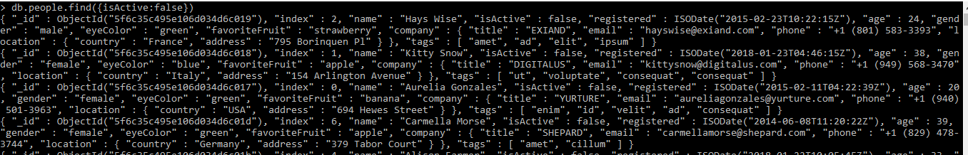

1. Query to find all of the documents where isActive:true;



1. Query to find number of documents where isActive:true;

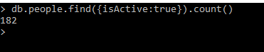

1. Query to find number of documents where isActive:false;



1. Query to create new documents showing the aggregate data of the isActive field

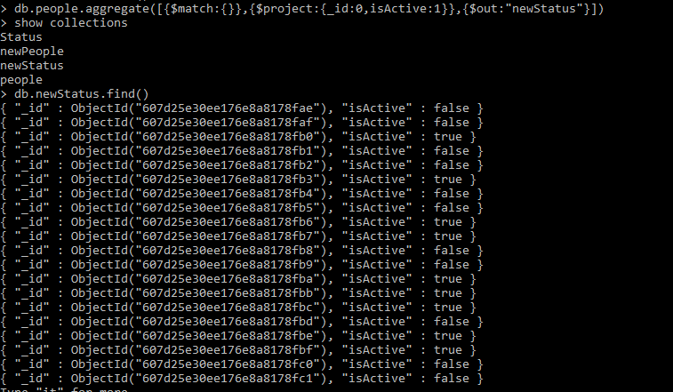

1. Query to create new documents showing the aggregate data of the isActive field and gender field

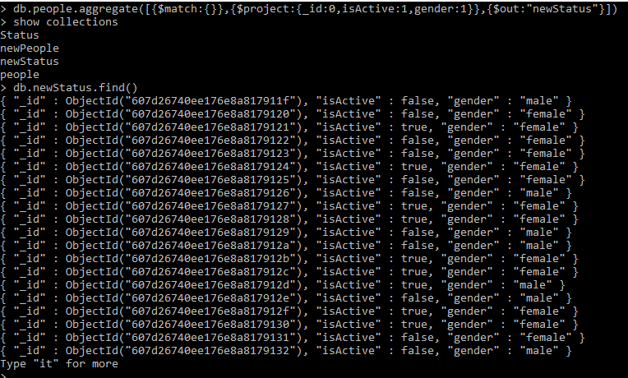

1. Query to create a new document showing the aggregate data of the isActive field and the age field, with the exception of anyone below the age of 35.

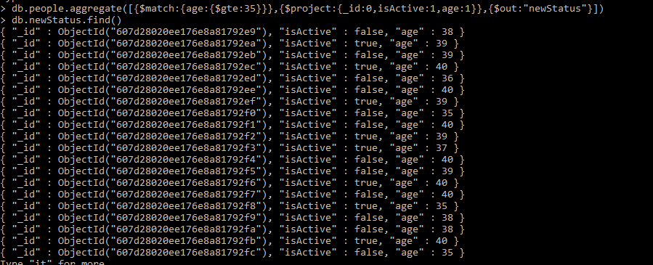

1. Sort the documents created in #7 in Ascending Order.

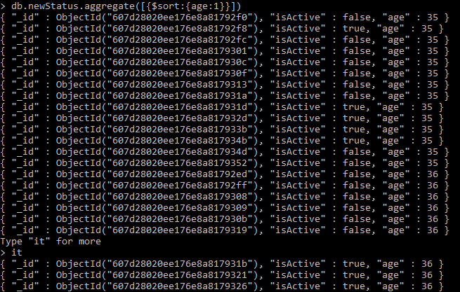

=========For 9-12, Kindly read ahead to Number 13 before proceeding===========

1. Query to create new documents showing the aggregate data of the number of companies found in a specific country. E.g USA: 5, Italy:10 , France: 15, etc.

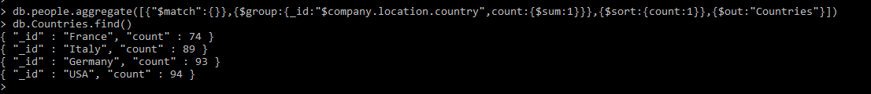

1. Query to create new documents showing the aggregate data of the number of documents associated to each specific tag. E.g ex:5, magna:10, enim: 10;

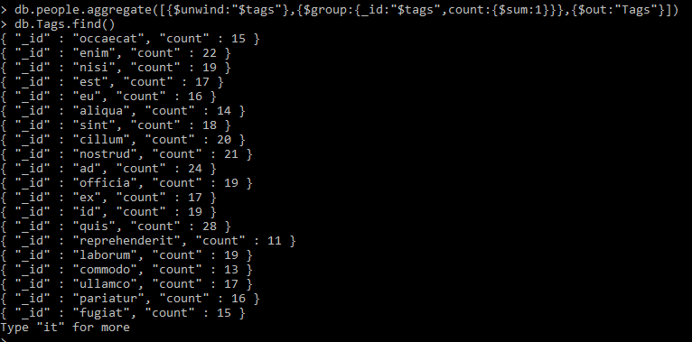

1. Query to sort the output of #10 in Descending Order

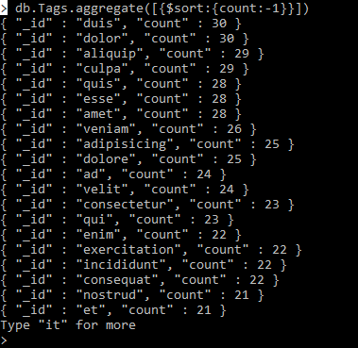

1. Query to create 2 new documents showing the average age of each gender.

e.g

{_id:female ,average:43};

{_id:male ,average:44};

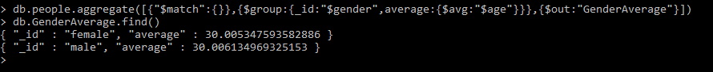

1. Query to output the documents of the ff numbers into specific collections
   1. Output the new documents produced by #10 into a collection called Tags
   2. Output the new documents produced by #9 into a collection called Countries
   3. Output the new documents produced by #12 into a collection called GenderAverage